A scientific review
The Rhizophagy Cycle - How plants eat?
The importance of the Rhizophagy Cycle, contributes to an
- Increased understanding of the symbiotic relationships between plants & microbes, leading to
- a future of new biological seed treatments
- We can now begin to understand WHY observations of bio stimulants & humic substances used currently have a positive impact on plant growth.

The research has developed a
- New focus on managing soil ecology for crop production with the aim to
- Reduce the use of crops inputs, and create
- A healthy environment, good quality available food and positive human health outcomes.
This extract is the work of a team collaboration & created as a Powerpoint Presentation and editorial to better understand & share this latest research. Booker.R, Mattinson.D, Coote.A. (2020)
This is a scientific review of the Rhizophagy Cycle and its importance to agriculture and food production focusing on the practical aspects of how plants eat and why it is important.
“Science is a way of knowing—an approach to understanding the natural world. It stems from our curiosity about ourselves and the world around us.” By knowing something we are able to understand it, how it works, how to improve it.
With more than 60% of land use in Australia under agricultural production, nearly 50% of that agriculture is plant based. Industrial Agriculture has created many common problems associated with mono culture crop production and land managers are now looking to the future to more regenerative agricultural practices.
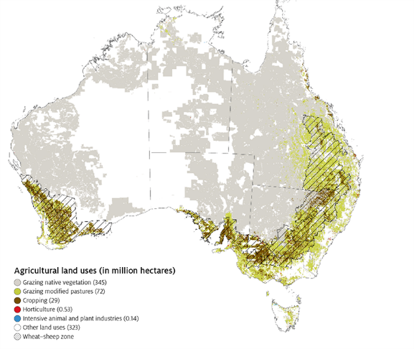
Source: Agriculture, Water and Environment, 2019

To protect our valuable soil we need to understand how to meet the needs of plants.
How do plants get the nutrients they need to survive?
Over time scientists have shown the symbiosis between plants and microbes as a means of gathering nutrients. In 2010 a group of scientists out of the University of Queensland showed evidence of plants actually consuming microbe’s as a source of nutrients, which they termed Rhizophagy. Building on this research in 2018, led by Professor James White at Rutgers University New Jersey his team have discovered the cyclic nature of the Rhizophagy process.
The peer reviewed paper we have gathered information from is Rhizophagy Cycle: An oxidative Process in Plants for nutrient extraction from symbiotic microbes, research led by Professor James F White and colleagues.
Our discussions with Professor White have reinforced the value of this research to agriculture. This research confirms that there is a cycle which occurs where the microbes enter the plant root carrying nutrients required by the plant.
“Using microbes could change entirely how we do agriculture, with a healthier planet and better nourished human population being the result.” Professor James White (April 2020 email to Anne Coote).

The nutrients are extracted and the microbes are forced back out of the root hairs to go and collect up more nutrients. In addition to the 4 institutions in the US, India and China, Australian research through the Soils CRC is also contributing to how this new research can enable change in soil management practices.
But it’s just the beginning. How we can create healthy soils to produce our food crops for the growing global population. This research has the potential to reduce the need for inorganic fertilisers and pesticides reduce soil & water contamination & provide us with nutrient dense food, healthier people and regenerative environment on a global scale.
Professor White and his colleagues began experiments to identify nutrient exchange between various symbiotic microbes on different seed species. These microscope experiments used a staining technique with the chemical DAB that highlight the release of a superoxide that plants use to degrade bacteria. Shown here with the brown pigment. Meanwhile, the introduced bacteria are counterstained with analine blue, that show where the bacteria move inside the plant root.
The Rhizophagy cycle begins with a free-living soil phase. This is where bacteria feed off root exudates and collect minerals from the soil.
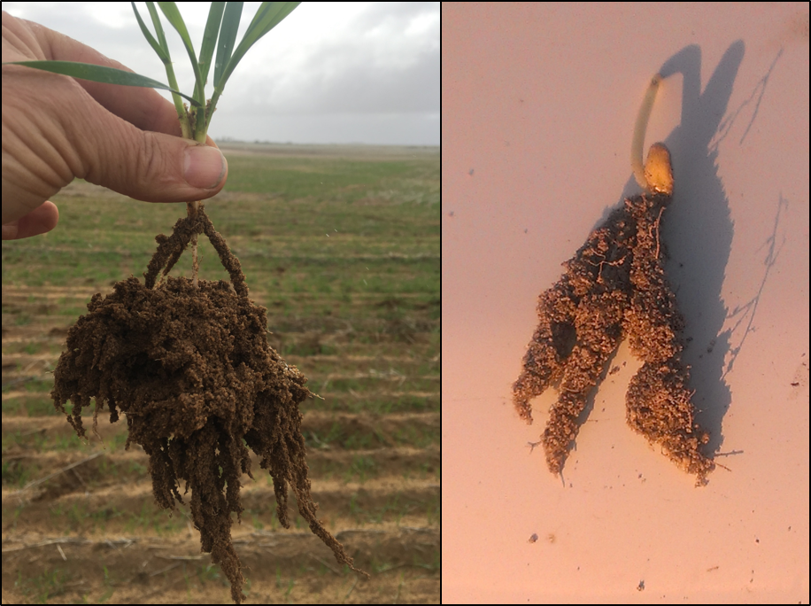
(White et al, 2018).

The second stage of Rhizophagy shows microbes entering the root meristem. This is a kind of endocytosis where the biofilm around the bacteria that helps move them across the membrane, and into the root.
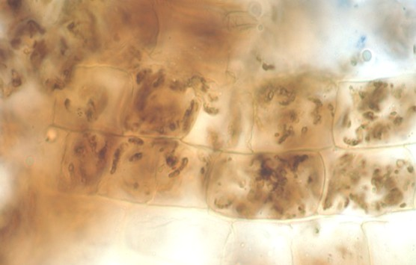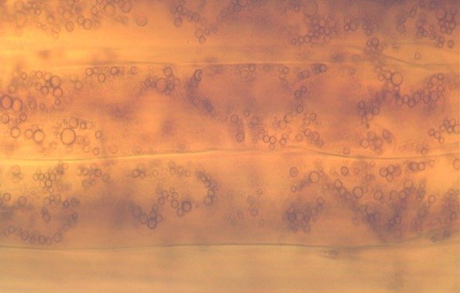
(White et al, 2018).

Next, the plant cell releases a highly oxidising Reactive Oxygen that strips the outer wall of the microbe, converting them to wall-less protoplasts.
As you see they become more transparent, and without a cell wall, the size and shape changes. Plants benefit from extracting the nutrients of the cell wall and the cytoplasm.
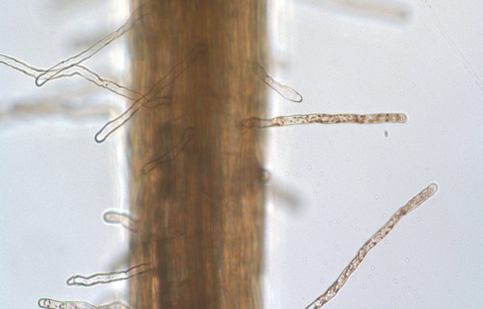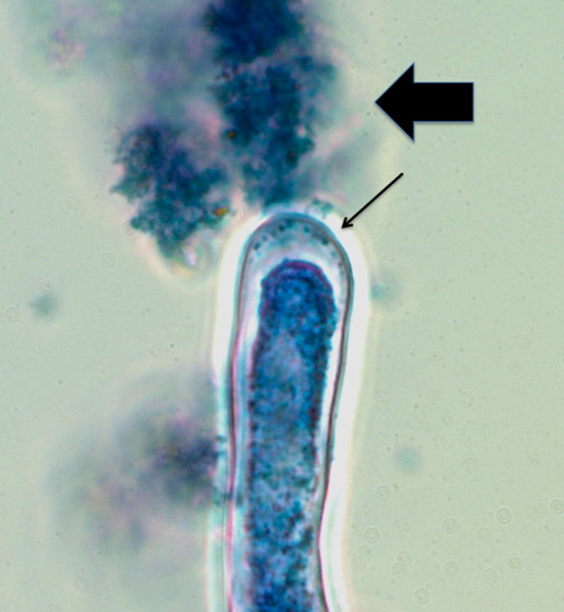
(White et al, 2018).

Some microbes don’t survive the highly oxidative environment, the ones that do begin to trigger fine root hair formation from the epidermal cells. This is where Professor White has been able to show the cyclic process of Rhizophagy. As the root hair elongates, bacteria begin to move along this structure, collecting at the tip before being expelled back into the soil matrix. The evidence is showing that once the bacteria are expelled the root hair stops growing. This is likely a function of the intracellular bacteria to help plants form a larger root structure to gather nutrients.
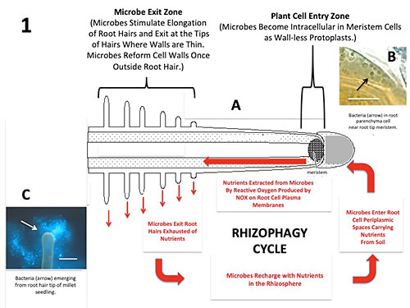
(White et al, 2018).

Once back in the rhizosphere, bacteria go on to reform cell walls, collect nutrients and start the cycle over again. It’s as if the plants are farming microbes, which gives a totally new context of plant nutrition.
This is really exciting research, so how do the scientists communicate their research to society? It is very important for scientists to ensure that they have information available for various sectors of the community to increase their knowledge and understand the significance of their research. In 2020 alone, this research on the Rhizophagy Cycle has been picked up by Soil Scientists around the world. Those in the Regenerative Agriculture space have had great exposure with field days, webinars and podcast from the likes of
Australian, Dr Christine Jones Amazing Carbon https://www.amazingcarbon.com/ Soil ecologist from NZ Nicole Masters https://www.integritysoils.co.nz/
And on the International stage John Kempf https://www.advancingecoag.com/john– presents a Q&A with James White, which is well worth a listen. Extension of this research on ‘the Rhizophagy Cycle’ has commenced and it’s getting great local, national and global recognition.
Another interesting outcome of this research was how some bacteria promoted growth in one species but impaired growth of another. Professor White is now conducting research into the use of this knowledge to potentially develop bio-herbicides using endophytic bacteria.

References:
Booker.R, Mattinson.D, Coote.A. (2020)

White, J. F., Kingsley, K. L., Verma, S. K., & Kowalski, K. P. (2018). Rhizophagy cycle: an oxidative process in plants for nutrient extraction from symbiotic microbes. Microorganisms, 6(3), 95. https://doi.org/10.3390/microorganisms6030095

